

面向对象程序设计实验课程
实验报告

实验项目名称：数组综合应用

学 院 计算机学院
班 级 计算机科学与技术3班
学 号 202421315062
姓 名 李懿
教 师 宋桂琴
实验日期 2025年3月7日

一、实验目的
（1） 熟练掌握一维数组的定义、初始化、输入、输出方法；
（2） 提高利用数组解决相关问题的能力；
（3） 掌握数组与函数的相关语法；
（4） 掌握与数组有关的常用算法（如查找、排序等）。

二、实验内容及要求
设计一个整型数组操作库，要求设计用户界面 。
功能：
1.数组输入
2.数组排序
3.元素插入
4.元素查找
5.元素删除
6.数组输出
7.输出指定位置元素
8.对指定个数的数组元素求和

三、参考代码及测试情况
1.参考代码:
// demo.cpp
#include <limits>
#include "custom_vector.h"
#include "ui.cpp"
#include <iostream>
using namespace std;

custom_vector v;

void current_situation()
{
cout << "当前元素数：" << v.get_size() << endl;
cout << "当前元素：" << endl;
for (size_t i = 0; i < v.get_size(); i++)
{
cout << v[i] << " ";
}
cout<<endl;
}

void input_1()
{
long long temp;
cout << "请输入元素(非数字结束）：" << endl;
while (cin >> temp)
{
v.push_back(temp);
}
if (cin.fail()) {
cin.clear(); // Clear the error flags
cin.ignore(numeric_limits<streamsize>::max(), '\n'); // Discard the invalid input
}
}

void input_2()
{
size_t nums;
long long temp;
cout << "请输入需要插入的数字数:";
cin >> nums;
cout << "请输入需要插入的数字:" << endl;
while (nums--)
{
cin >> temp;
v.push_back(temp);
}
cin.ignore(numeric_limits<streamsize>::max(), '\n');
cin.clear();
}

void sort()
{
v.sort();
}

void insert()
{
cout << "请输入插入位置：";
size_t offset;
cin >> offset;
cin.ignore(numeric_limits<streamsize>::max(), '\n');
cin.clear();
cout << "请输入插入元素：";
long long temp;
cin >> temp;
cin.ignore(numeric_limits<streamsize>::max(), '\n');
cin.clear();
v.insert(offset, temp);
}

void erase()
{
cout << "请输入删除位置：";
size_t offset;
cin >> offset;
v.erase(offset);
}

void find()
{
cout << "请输入查找元素：";
long long temp;
cin >> temp;
size_t offset = v.find(temp);
if (offset == size_t(-1))
{
cout << "没有结果" << endl;
return;
}
while (offset != size_t(-1))
{
cout << "查找结果：" << offset << endl;
offset = v.find(temp,offset+1);
}
}

void pos()
{
cout << "请输入查找位置：";
size_t offset;
cin >> offset;
cout << "查找结果：" << v[offset] << endl;
}

void sum1()
{
cout << "请输入求和开始位置";
size_t begin_offset;
cin >> begin_offset;
cout << "请输入求和结束位置";
size_t end_offset;
cin >> end_offset;
cout << "求和结果：" << v.sum(begin_offset, end_offset) << endl;
}

void introduction()
{
cout << "功能:\n\
0.退出 \n\
1.数组输入 \n\
2.数组排序 \n\
3.元素插入 \n\
4.元素查找 \n\
5.元素删除 \n\
6.数组输出 \n\
7.输出指定位置元素 \n\
8.对指定个数的数组元素求和\n\
9.数组状态查询\n\
10.数组自由插入\n\
";
}

void choice()
{
short choice = 9;
while (choice != 0)
{
introduction();
printline();
cout << "你的选择是：";
cin >> choice;
cin.ignore(numeric_limits<streamsize>::max(), '\n');
cin.clear();
switch (choice)
{
case 1:
input_2();
break;
case 2:
sort();
break;
case 3:
insert();
break;
case 4:
find();
break;
case 5:
erase();
break;
case 6:
current_situation();
break;
case 7:
pos();
break;
case 8:
sum1();
break;
case 9:
current_situation();
break;
case 10:
input_1();
break;
case 0:
break;
default:
break;
}
printline();
}
}

int main()
{
choice();
return 0;
}

//custom_vector.h
#pragma once
#ifndef _CUTOM_VECTOR_MODIFY_H_
#define _CUTOM_VECTOR_MODIFY_H_

#define _custom_type long long

#include <algorithm>
#include <istream>
#include <ostream>
#include <string>
#include <exception>

class custom_vector
{
public:
custom_vector() : data(nullptr), size(0), capacity(0) {}
~custom_vector(){ delete[] data; }
custom_vector operator= (const custom_vector & right);
_custom_type operator[](size_t offset);
void sort();
void sort(auto cmp = [](_custom_type x, _custom_type y)
{ return x > y; });
void push_back(_custom_type value);
void push_front(_custom_type value);
void insert(size_t offset, _custom_type value);
size_t find(_custom_type value, size_t offset = 0);
void erase(size_t offset);
_custom_type sum(size_t begin,size_t end);
friend std::ostream &operator<<(std::ostream &os, custom_vector &v);
friend std::istream &operator>>(std::istream &is, custom_vector &v);
_custom_type * begin();
_custom_type * rbegin();
_custom_type * rend();
_custom_type * end();
size_t get_size() const;

protected:
void update_capacity(size_t target_size);

private:
_custom_type *data;
size_t size;
size_t capacity;
};

#include "custom_vector.cpp"
#endif

// custom_vector.cpp
#pragma once
#ifndef CUSTOM_VECTOR_CPP
#define CUSTOM_VECTOR_CPP
#include "custom_vector.h"

_custom_type custom_vector::operator[](size_t offset)
{
if (offset >= size)
{
throw std::out_of_range("Out of range");
}
return data[offset];
}
void custom_vector::push_back(_custom_type value)
{
if (size >= capacity)
{
update_capacity(capacity == 0 ? 1 : capacity * 2);
}
data[size++] = value;
}
void custom_vector::push_front(_custom_type value)
{
if (size >= capacity)
{
update_capacity(capacity == 0 ? 1 : capacity * 2);
}
for (size_t i = size; i > 0; i--)
{
data[i] = data[i - 1];
}
data[0] = value;
size++;
}
void custom_vector::insert(size_t offset, _custom_type value)
{
if (offset > size)
{
throw std::out_of_range("out of range");
}
if (size >= capacity)
{
update_capacity(capacity == 0 ? 1 : capacity * 2);
}
for (size_t i = size; i > offset; i--)
{
data[i] = data[i - 1];
}
data[offset] = value;
size++;
}
size_t custom_vector::find(_custom_type value, size_t offset)
{
for (size_t i = offset; i < size; i++)
{
if (data[i] == value)
{
return i;
}
}
return size_t(-1);
}
void custom_vector::erase(size_t offset)
{
if (offset >= size)
{
return;
}
for (size_t i = offset; i < size - 1; i++)
{
data[i] = data[i + 1];
}
size--;
}
std::ostream &operator<<(std::ostream &os, custom_vector &v)
{
for (size_t i = 0; i < v.size; i++)
{
os << v[i] << " ";
}
return os;
}
std::istream &operator>>(std::istream &is, custom_vector &v)
{
for (size_t i = 0; i < v.size; i++)
{
is >> v.data[i];
}
return is;
}
_custom_type *custom_vector::begin()
{
return data;
}
_custom_type *custom_vector::end()
{
return data + size;
}
_custom_type *custom_vector::rbegin()
{
return data + size - 1;
}
_custom_type *custom_vector::rend()
{
return data - 1;
}

void custom_vector::update_capacity(size_t target_size)
{
if (target_size < 0)
{
return;
}
else if (target_size <= capacity)
{
return;
}
else
{
_custom_type *temp = new _custom_type[target_size];
for (size_t i = 0; i < size; i++)
{
temp[i] = data[i];
}
delete[] data;
data = temp;
capacity = target_size;
}
}
custom_vector custom_vector::operator=(const custom_vector &right)
{
if (this == &right)
{
return *this;
}

update_capacity(right.capacity);
size = right.size;

for (size_t i = 0; i < size; ++i)
{
data[i] = right.data[i];
}

return *this;
}
void custom_vector::sort()
{
std::sort(data, data + size);
}
void custom_vector::sort(auto cmp)
{
std::sort(data, data + size, cmp);
}
size_t custom_vector::get_size() const
{
return size;
}

_custom_type custom_vector::sum(size_t begin, size_t end)
{
_custom_type all = 0;
if (begin < 0 || end >= size)
{
throw std::out_of_range("out of range");
}
while(begin<=end){
all += data[begin++];
}
return all;
}

#undef _custom_type
#endif

//ui.cpp
#pragma once
#include <iostream>
#include <string>
#include <iomanip>

#if defined(WIN32) || defined(_WIN32) || defined(__WIN32__) || defined(__NT__)
#include <windows.h>
#endif

int consoleWidth, consoleHeight;
std::ostream &os = std::cout;
bool uninit = true;

#if defined(WIN32) || defined(_WIN32) || defined(__WIN32__) || defined(__NT__)
// 获取当前控制台的宽度和高度 windows only
void init_windows()
{
HANDLE console = GetStdHandle(STD_OUTPUT_HANDLE);
CONSOLE_SCREEN_BUFFER_INFO bufferInfo;
GetConsoleScreenBufferInfo(console, &bufferInfo);
consoleWidth = bufferInfo.dwSize.X;
consoleHeight = bufferInfo.dwSize.Y;
uninit = false;
}

#else
void init()
{
consoleHeight = 128;
consoleWidth = 46;
}
#endif

void printline()
{
if (uninit)
{
init_windows();
}
for (int i = 0; i < consoleWidth; i++)
{
os << "*";
}
os << std::endl;
}

void clear_screen()
{
system("cls");
}
void after_finish()
{
os << "*";
system("pause");
clear_screen();
}
void waiting()
{
os << "*";
system("pause");
}

void print_line(std::string str)
{
if (uninit)
{
init_windows();
}
os << std::setw(consoleWidth - 1) << std::left << "*" + str << "*" << std::endl;
}
void input_line(std::string str)
{
if (uninit)
{
init_windows();
}
os << std::setw(consoleWidth - 1) << std::left << "*" + str << "*";
for (int i = (consoleWidth - 2); i > str.length(); i--)
{
os.put('\b');
}
}

2.测试结果(截屏)
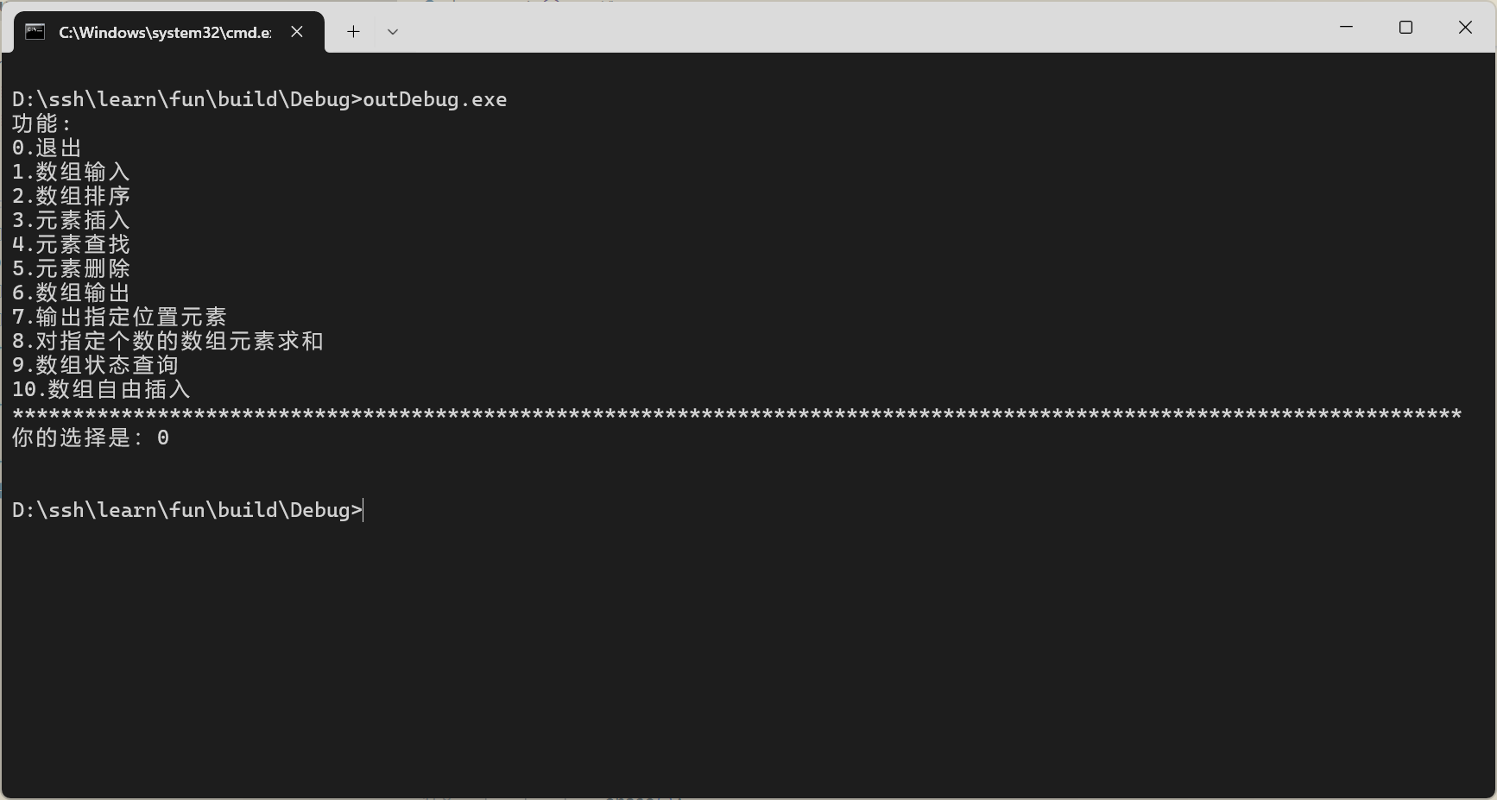
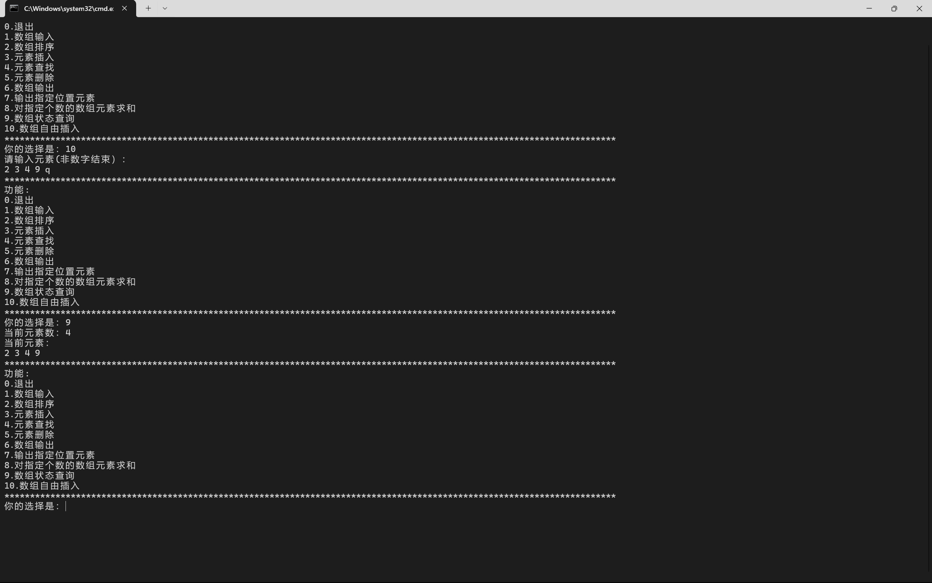
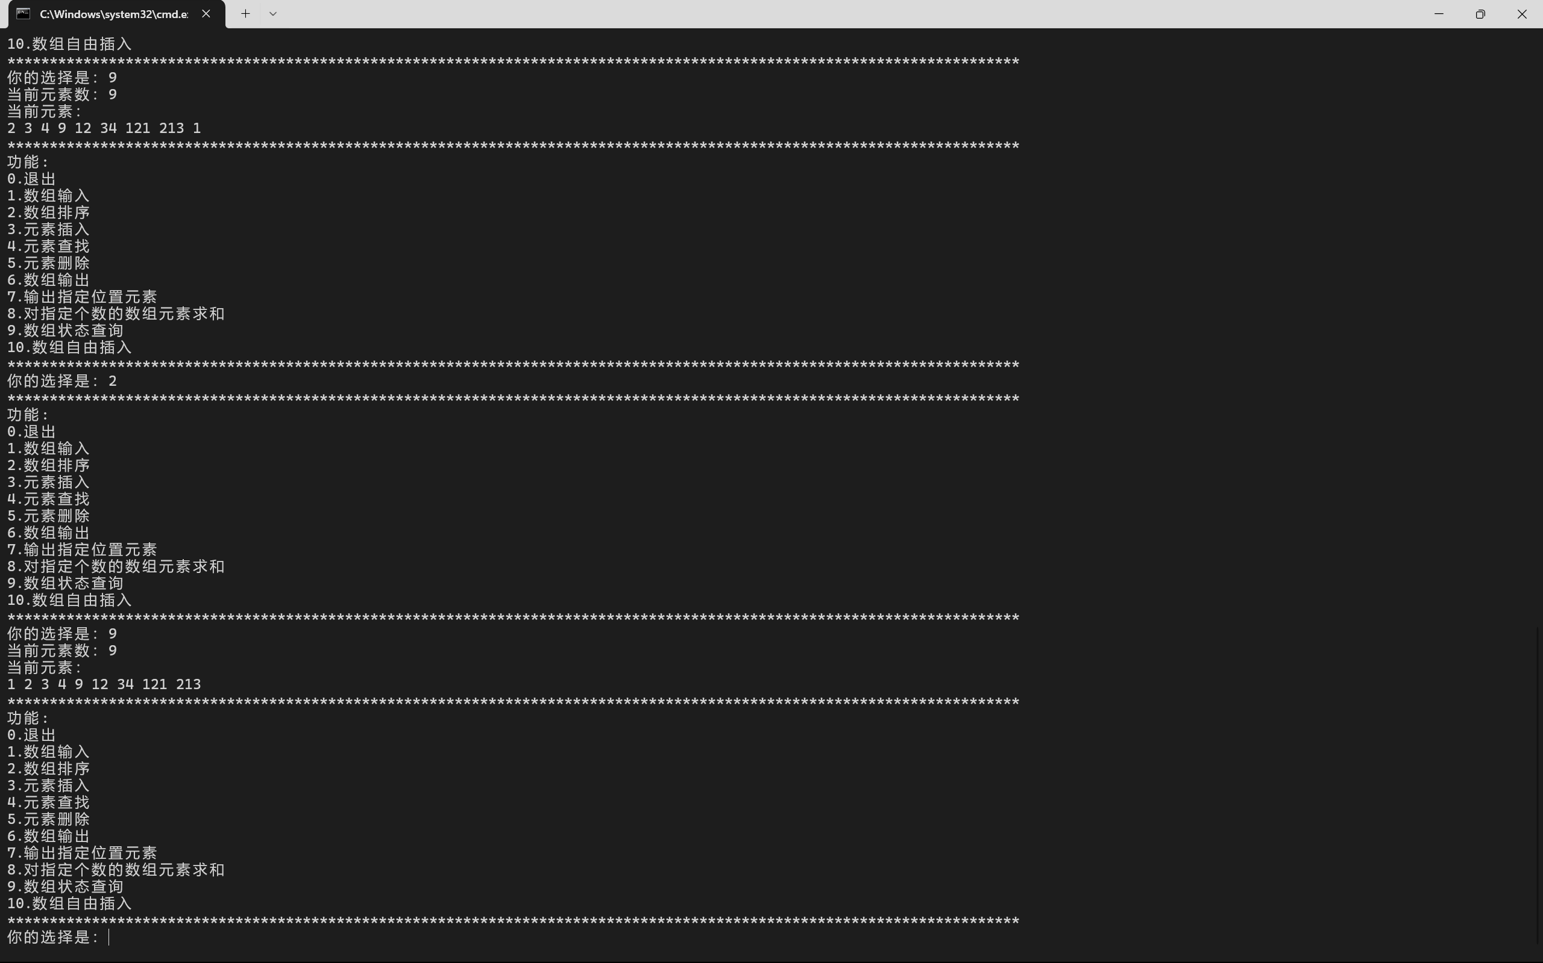
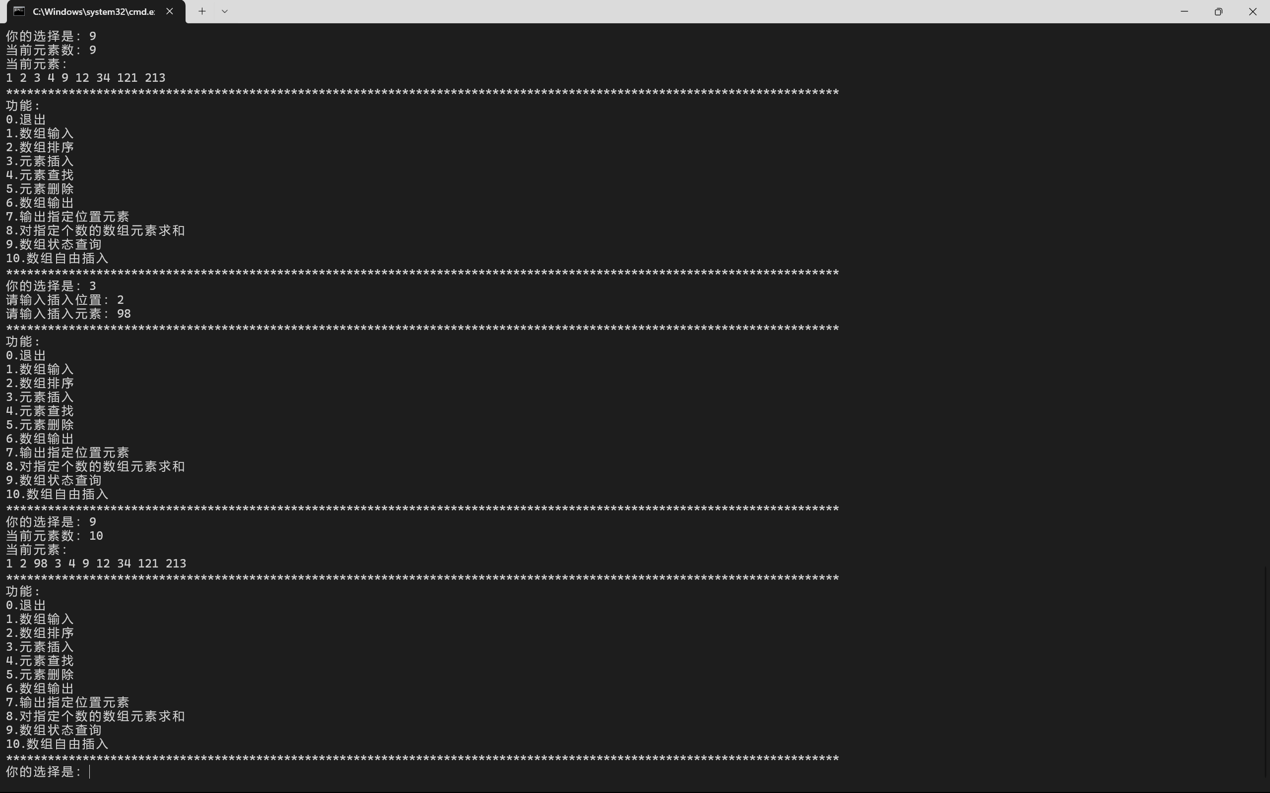
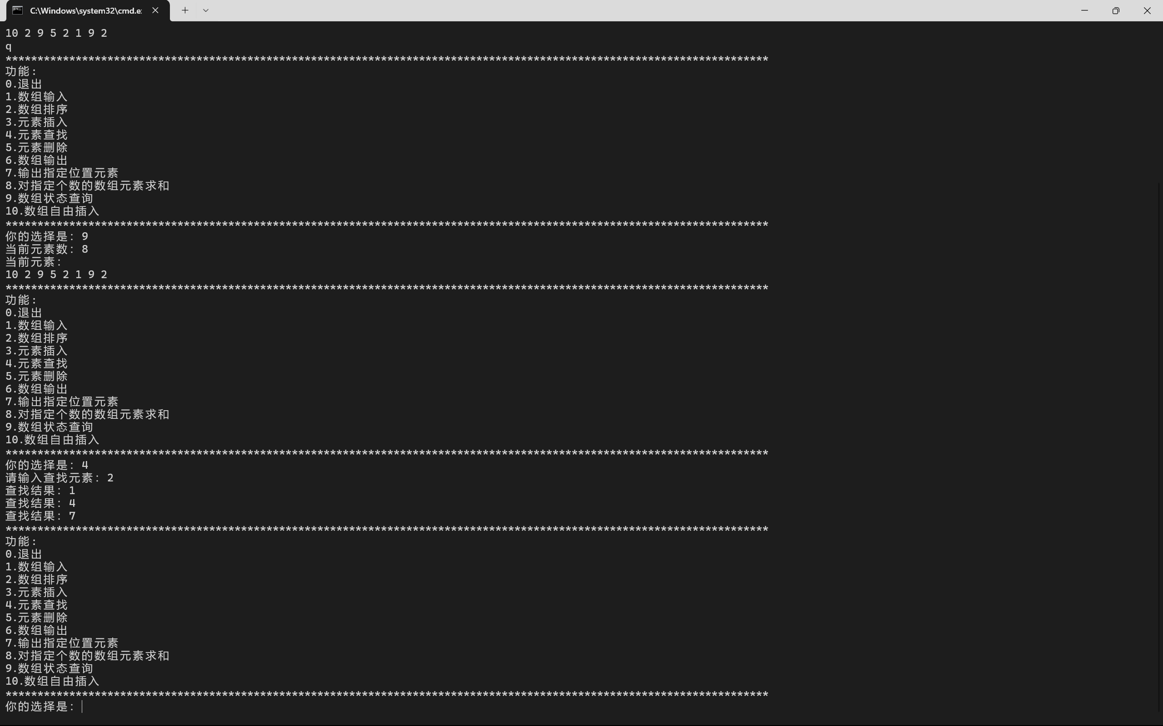
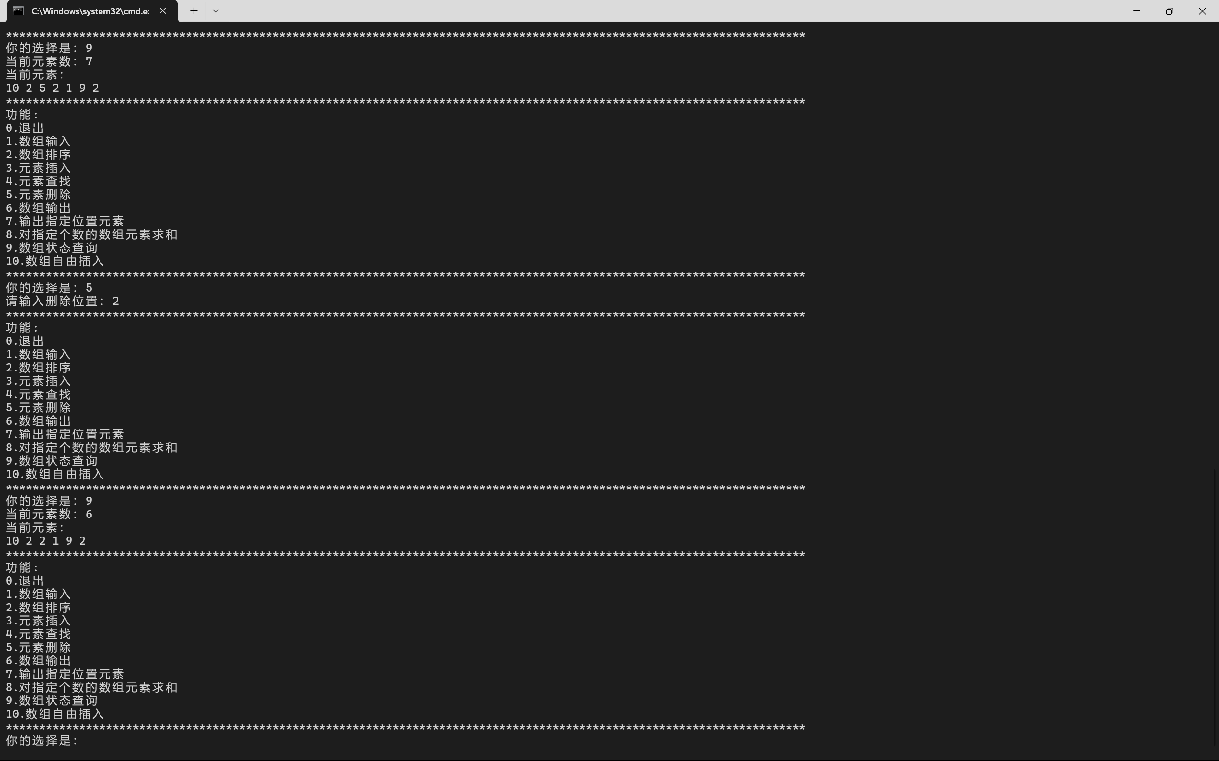

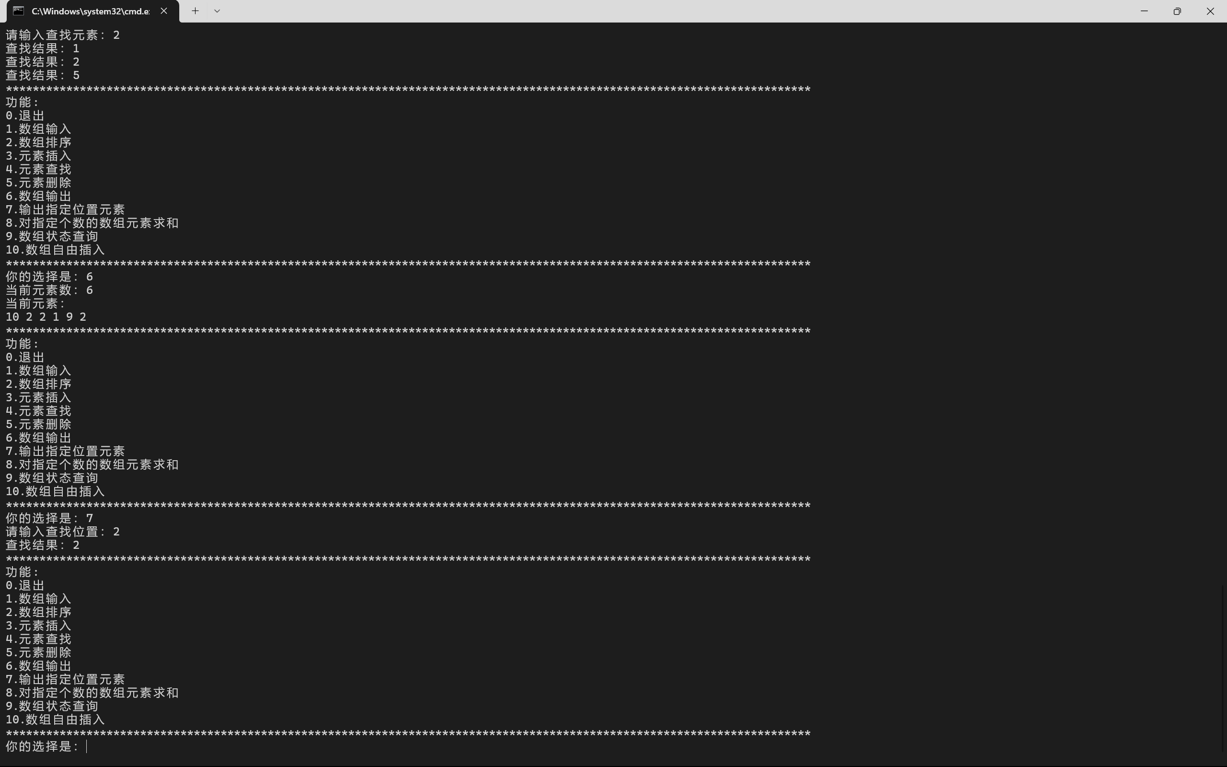
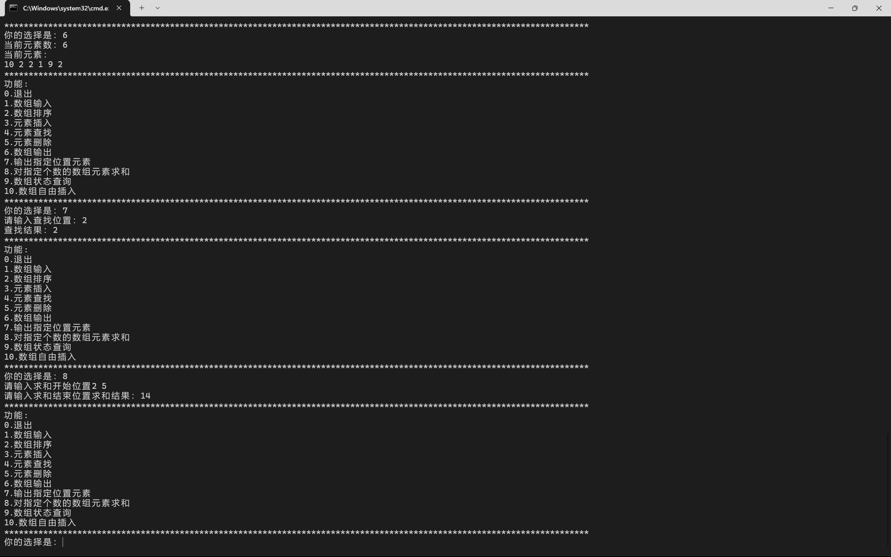

四、实验总结
（此处给出本次实验的心得体会）
初步实现了一个动态数组，可以自动扩容，访问内部元素，暂时使用浅拷贝，
自定义的这个动态数组采用了边界检查，对象销毁时自动删除内部的内存，采用宏定义，方便修改内部数据类型
输入后自动清理缓冲区
复用ui库
不足：没有实现深拷贝和模板化

